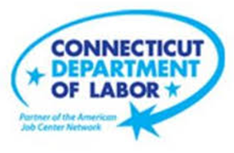

**NEW WEEKLY JOB POSTINGS FROM   
HELP WANTED ONLINE  
Office of Research**

**Week Ending December 3rd, 2022: New Ads Increase After a Thanksgiving Drop**WETHERSFIELD, December 9th, 2022 – During the week ending December 3rd, there were 5,919 new postings, up 197 new ads or +3% over the week. Fourteen industries increased over the week and seven decreased. Accommodation & Food Services (+138 new ads) and Professional, Scientific, & Technical Services (+96 new ads) had the largest increases. The largest decreases occurred in Educational Services (-130 new ads) and Manufacturing (-71 new ads). The Largest employer increases in Accommodation & Food Services were Colony Grill (+20 new ads) and KFC (+10 new ads). The largest declines in Educational serices occurred at CCSU (-31 new ads) and the Norwalk Public School District (-11 new ads). The sharp new ad drop in late November corresponds with Thanksgiving and is shown in the graph below to have occurred at both the state and national levels. Prior years exhibited similar drops around the holiday and had new ad rebounds in subsequent weeks.  
  
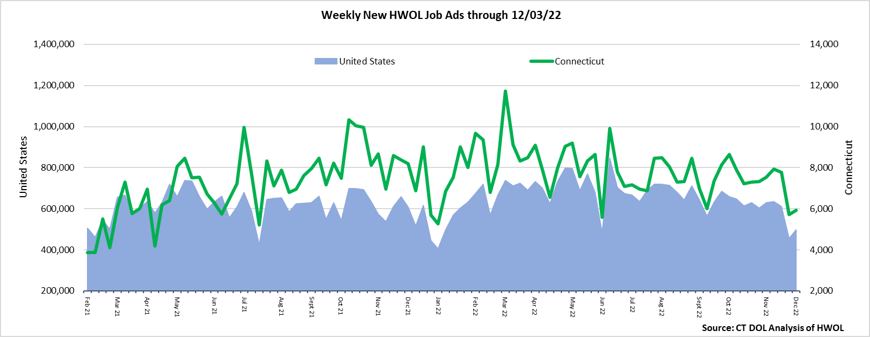  
**Industries** with the most new postings include Health Care & Social Assistance, Retail Trade, and Manufacturing.

**Occupations** with the most new postings include Registered Nurses, Retail Salespersons, and Wholesale & Manufacturing Sales Representatives.

**Employers** with the most new postings include Community Health Center Inc., Yale-New Haven Health System, and CDW Corporation.

**The three industries with the most new job postings were:**

* **Health Care & Social Assistance** (1,559 new postings, +6% over the week)
* **Retail Trade** (491 new postings, -3% over the week)
* **Manufacturing** (456 new postings, -13% over the week)

   
 During the week ending December 3rd, 2022, the 3% new ad total increase is the net result of increases in fourteen industries and decreases in seven industries. The fourteen increasing industries grew by a combined 522 new ads and 45% of that combined increase occurred in Accommodation & Food Services (+138 new ads) or Professional, Scientific, & Technical Services (+96 new ads). The seven decreasing industries fell by a combined 325 new ads, Educational Services was down the most (-130 new ads). Over four weeks, total ads were down 22%, fifteen industries were down, two were unchanged, and four were up. The largest four week industry decrease was Manufacturing (-353 new ads) and the largest increase was Accommodation & Food Services (+21 new ads).  
  
 For more information on total job ads by industry for Connecticut and its labor market areas, see the monthly report available here: <https://www1.ctdol.state.ct.us/lmi/hwol.asp>

**New Job Postings by Occupation** 

**The occupations with the most new postings were:**

* Registered Nurses (338 new postings, -18% over the week)
* Retail Salespersons (169 new postings, -11% over the week)
* Sales Representatives, Wholesale & Manufacturing (163 new postings, +47% over the week)

**Employers with the Most New Job Postings**  Employers with the most new job postings during the week were mostly in Healthcare & Social Assistance, Finance & Insurance, and Retail Trade. The 25 employers shown above account for 21 percent of all new ads. 21 of 25 employers in the top 25 increased over the week, one was unchanged and three decreased. The top 25 employers with the largest over the week increase and decrease respectively were Community Health Center, Inc. (+192 new ads) and Yale-New Haven Health System (-38 new ads).   
  
**What is HWOL?**The **Conference Board Help Wanted Online**® Data Series (HWOL) measures the number of new, first-time Online job postings and jobs reposted from the previous month for over 16,000 Internet job boards, corporate boards, and smaller job sites that serve niche markets and smaller geographic areas. To view more HWOL data, go to: <https://www1.ctdol.state.ct.us/lmi/hwol.asp>